Join the 1st CROPDIVA international symposium in Ghent, 4-6 December 2023
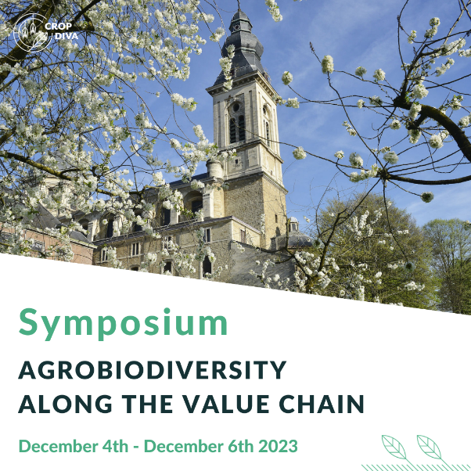

From the 4th to the 6th of December 2023, CROPDIVA welcomes guests from all over the world for its first international symposium ‘Agrobiodiversity along the value chain’ in Ghent, Belgium.
The Symposium will discuss several aspects of agrobiodiversity along the value chain and will include a general session with two invited speakers:
- Prof. dr. Johan Six (ETH Zürich, Switzerland): "Agrobiodiversity from a global perspective"
- Prof. dr. Andreas Börner (IPK-Gatersleben, Germany): “Genebanks – a reservoir for increasing agrobiodiversity"
Further in the programme, there will be several sessions with submitted abstracts related to the following topics:
- Genetics: How they shape agrobiodiversity?
- The impact of cropping systems on agrobiodiversity
- Food and feed technology, drivers of change on agrobiodiversity
- Agrobiodiversity: the challenges and opportunities for socio-economic sciences
Abstracts for an oral or poster presentation at the symposium can be uploaded on the website (deadline 15 September 2023).
Registration is open now on the website (reduced registration fee until 15 September 2023).
Visit the symposium website on www.cropdivasymposium.eu.

